EXPERIMENT 5

**Title:  To understand and use SQL Sub-Query**

**Objective:** To understand the use of sql subquery.

1. CREATING TABLES

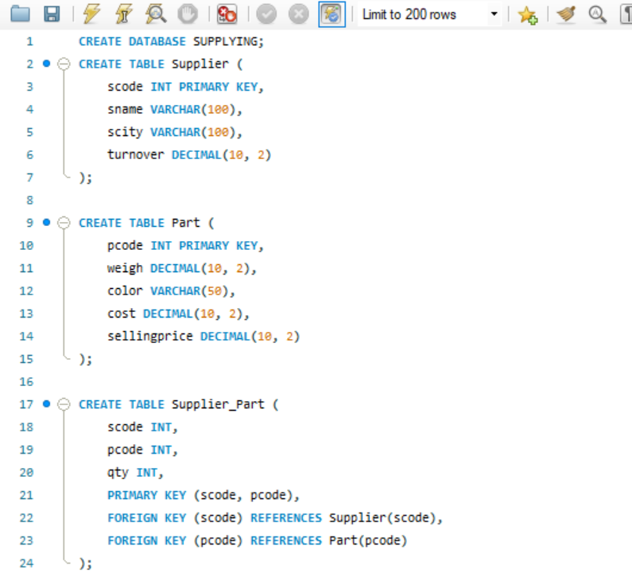

1. INSERTING VALUES

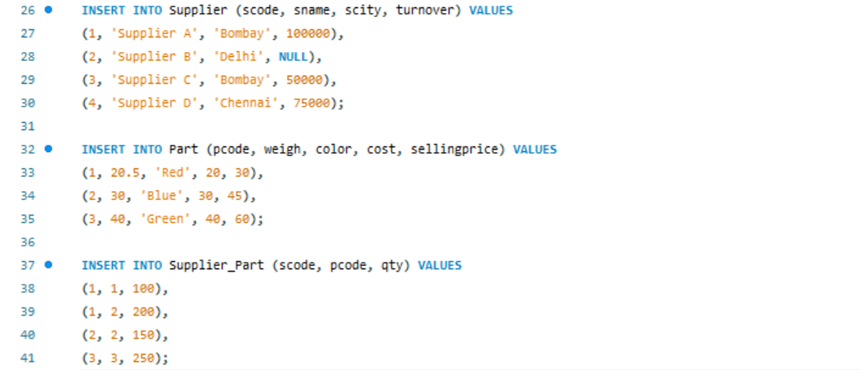

1. SQL QUERIES

